**Module 2. Human use**

**Draft 08-18-2022**

**MLPA Goal:** 3 and 5 (to a degree)

**Guiding DEWG questions: N1**, **N4**, **N10**, **25**

**Overarching question:** How is human engagement distributed across the network and does the network produce equitable user benefits?

**Overarching response:** Human engagement across the MPA network is correlated to nearby population density, but some MPAs that are adjacent to state parks (with associated infrastructure) show higher engagement than would be predicted by population density alone.

**Key findings:**

* Engagement in MPAs is largely proportional to population density (no. of people within 50 km), but some ‘high performing’ MPAs have shared traits that further expand human use.
* MPAs affiliated with state parks, national marine sanctuaries, and that have sandy beaches and estuaries show disproportionately high engagement relative to population density.
* Engagement in MPAs could be promoted by developing land-based infrastructure that eases access to coastal MPAs or by co-locating new MPAs with existing infrastructure during the design phase.

*Overview*

We characterized human uses of California’s marine protected areas throughout the network and identified traits that contribute to human engagement in protected areas. We assembled and evaluated indicators of human use that capture a diversity of recreational, educational, and scientific uses across the MPA network (i.e., for MPAs only). We relate the level of human use to population density, accessibility, and other MPA traits. Overall, we illustrate the many ways in which people use protected areas and identify traits associated with high human engagement. Results indicate that human use inside MPAs is generally correlated to nearby population density, but discovered MPAs that have higher engagement than would be predicted by population density alone. These “charismatic” sites are near tourist destinations and are often adjacent to state parks and associated infrastructure. Therefore, we infer that engagement in MPAs can be promoted by developing land-based infrastructure that eases access to coastal MPAs or by co-locating new MPAs with existing infrastructure during the design phase. Additionally, these results may inform prioritization of monitoring, enforcement, education, and outreach programs.

*Methods*

We used several community-based data platforms as indicators for measuring engagement across the MPA network, including MPA Watch ([MPA Watch, 2022](https://www.zotero.org/google-docs/?HSrpFe)), iNaturalist ([iNaturalist, 2022](https://www.zotero.org/google-docs/?Unmwvc)), eBird ([eBird, 2022](https://www.zotero.org/google-docs/?gK2fht)), and Reef Environmental Education Foundation (REEF; [REEF, 2022](https://www.zotero.org/google-docs/?IryJCQ)). These indicators are community science programs where individuals can submit spatially referenced records of activities (e.g., fishing, watersport activities, etc.) or observations of wildlife. Therefore, these programs serve as useful indicators for evaluating human engagement across the MPA network. We also used data collected by California Department of Fish and Wildlife (CDFW) to quantify scientific research activity and regulatory compliance within California’s MPA network.

To compare human use across the MPA network, we standardized the various sources of human use data to allow comparison in an ‘engagement scorecard.’ We scaled each indicator to ease comparison (**Figure 1**). After visually inspecting the results of the scorecard, it was clear that some MPAs have higher engagement beyond what might be explained by population density alone. Therefore, we used a regression approach to explicitly evaluate the degree to which engagement is explained by population density. For this regression model, we used the number of iNaturalist observers as our measure of engagement because iNaturalist is the most spatially comprehensive indicator and includes most of the MPAs within the network and correlates well with other indicators. Any MPAs with residuals greater than 100% of the fitted values of the regression were classified as “charismatic”, where engagement is higher than would be expected based on population density. Finally, we conducted a logistic regression to evaluate drivers of human use that may explain charismatic MPAs beyond population density alone. These potential drivers included infrastructure and environmental attributes (Table 1).

*Results*

We found that human use inside protected areas is generally correlated to nearby population density across most indicators. Citation and research permit data were more aggregated (i.e., annual sums) than the other indicators of human use. In general, citation frequency was positively correlated with local human population density and MPA engagement (as measured using the spatially and temporally expansive iNaturalist indicator). Among all human uses, scientific research has been the most evenly spread activity across the MPA network, with all but one MPA receiving scientific attention. We also found that particular site characteristics can expand human use beyond what would be predicted by population density alone, resulting in 'charismatic’ sites. A linear regression on the number of iNaturalist observers within MPAs as predicted by nearby population density provided relatively strong fit after removing 18 ‘charismatic’ MPAs that were not explained by population density alone (**Figure 2;** r2=0.47; p<0.001). Results from the logistic regression revealed that engagement in charismatic MPAs is best explained by having an affiliation with a state park or National Marine Sanctuary, sandy beaches, or an estuary (**Table 1**).

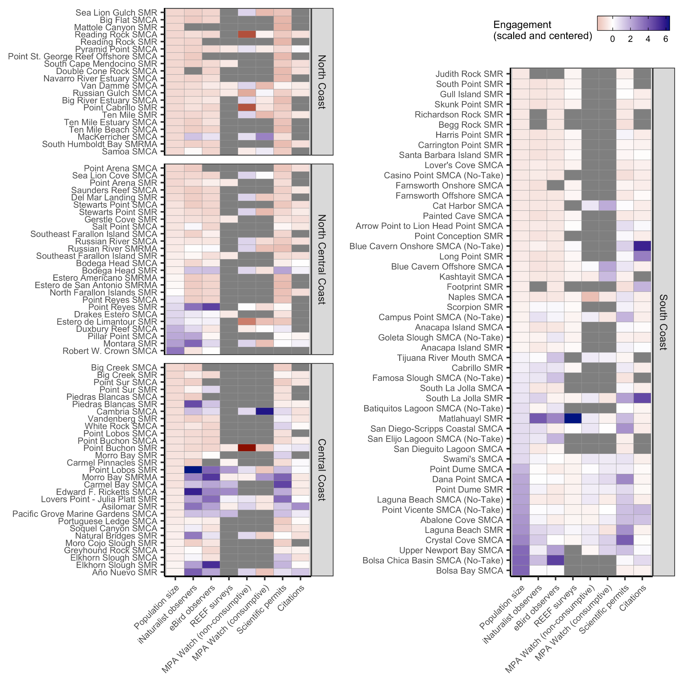

**Figure 1.** A synthesis of human use indicators within California’s state marine protected areas (MPAs). MPAs are organized by region and are sorted by population density within 50 km (first column of each plot). Human use indicators are centered and scaled to ease comparison across indicators; thus, blue shades indicate MPAs with above average engagement and red shades indicate MPAs with below average engagement. Gray indicates MPAs without data.

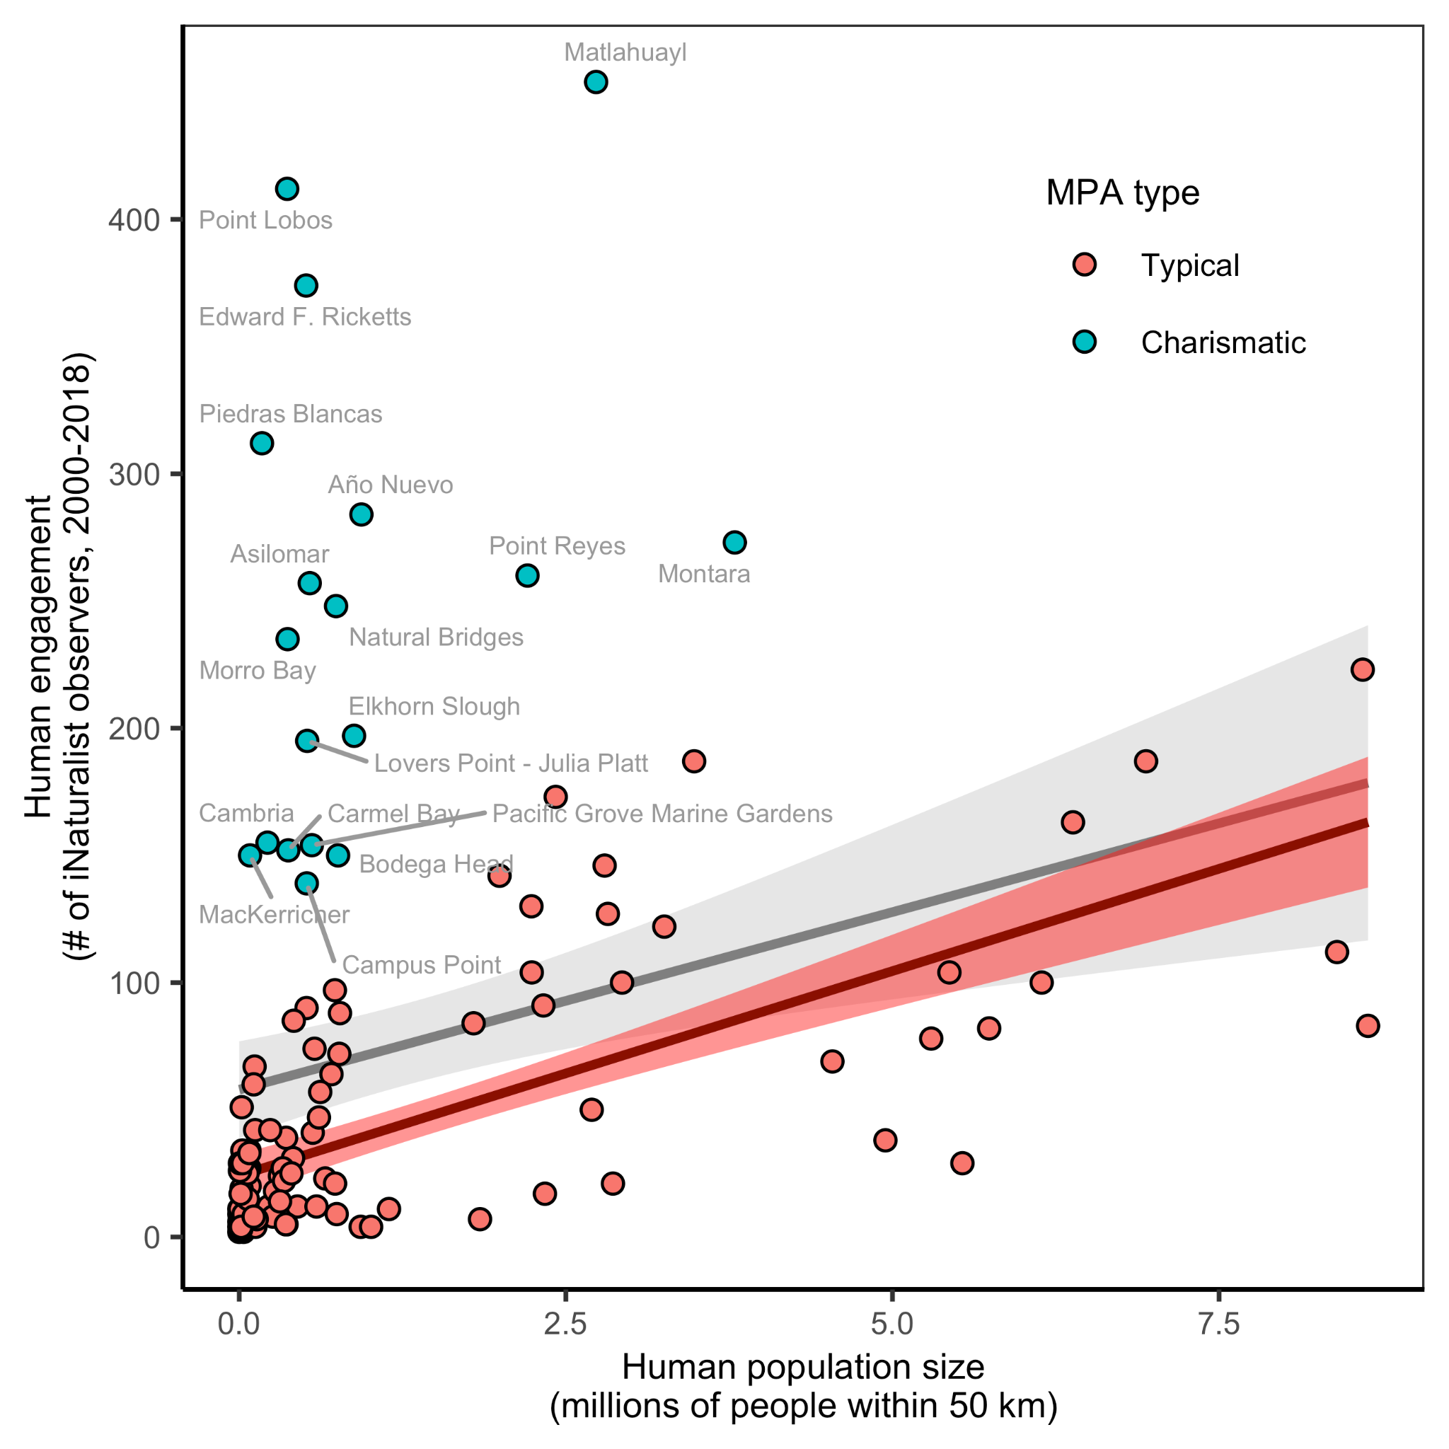

**Figure 2.** Correlation between human engagement in a marine protected area and the number of people living within 50 km of a protected area. Human engagement is measured as the number of iNaturalist observers submitting observations within 100 m of a protected area. The gray line and 95% confidence interval illustrate a linear regression (r2=0.08; p=0.0009) fit to all points. Points with residuals greater than 100% of the fitted values were classified as “charismatic” protected areas, whose engagement is higher than would be expected based on population density. The charismatic MPAs are labeled with their abbreviated name. The red line and 95% confidence interval illustrate a linear regression (r2=0.47; p<0.00001) fit to the “typical” protected areas, whose engagement is largely determined by population density.

**Table 1.** Physical and biological determinants of charismatic MPAs by type of engagement, based on the results of logistic regression. Missing values indicate the best fit model does not include the associated predictors.

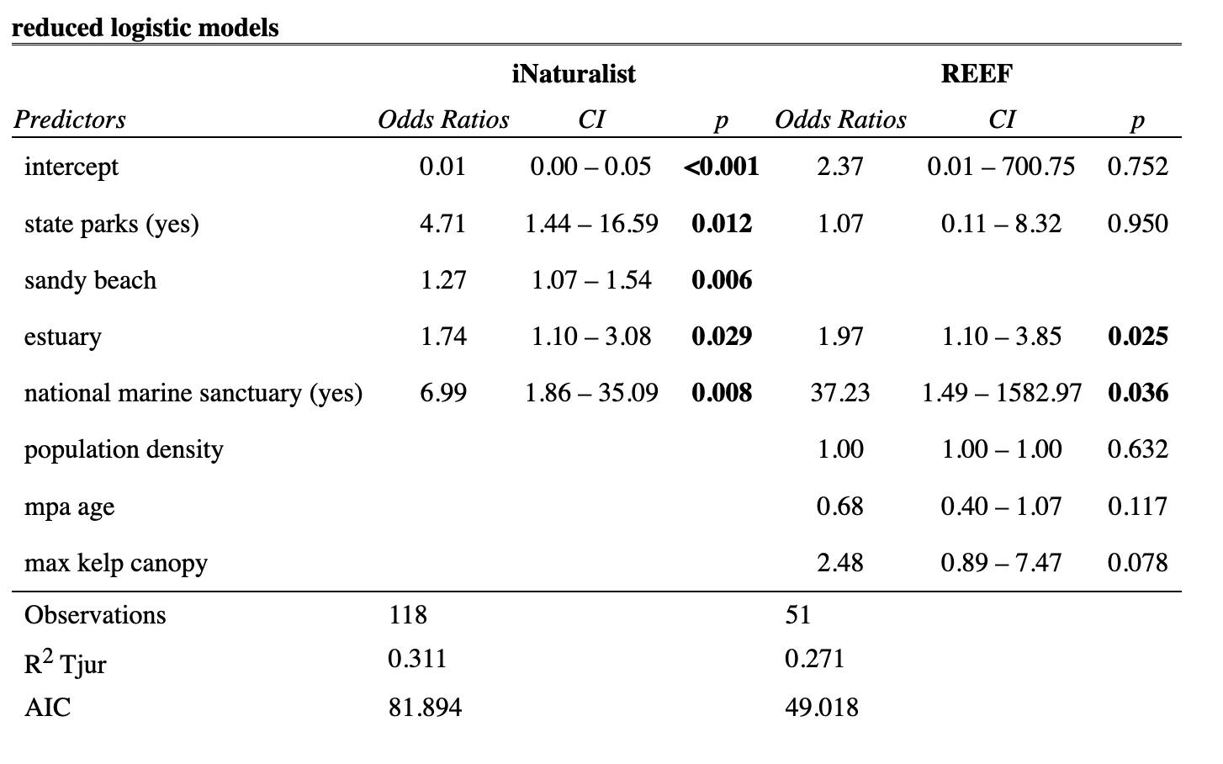

**References**

[eBird. (2022). *EBird Basic Dataset. Version: EBD_relMay-2022.* Cornell Lab of Ornithology.](https://www.zotero.org/google-docs/?AQK9JQ) <https://ebird.org/home>

[iNaturalist. (2022). *INaturalist*. INaturalist.](https://www.zotero.org/google-docs/?AQK9JQ) <https://www.inaturalist.org/>

[MPA Watch. (2022a). *MPA Watch*. MPA Watch.](https://www.zotero.org/google-docs/?AQK9JQ) <https://mpawatch.org/>

[REEF. (2022). *Reef Environmental Education Foundation*. www.REEF.org](https://www.zotero.org/google-docs/?AQK9JQ)